# Windows IoT Core Lab Setup

## Bring Your Own Device Setup Overview

Assuming you have Windows 10 installed then you will need to allocate about an hour for setup. If you also have Visual Studio Update 2 installed, then allocate about 20 minutes.

### Overview of software requirements for the labs.

1. **Windows 10** (running on the metal ie not virtualized)

As at April 2016 build 10.0.10586. Up to date and fully patched. You can upgrade to Windows 10 from [here](http://www.microsoft.com/en-us/software-download/windows10). If you are already running Windows 10, you can find your current build number by clicking the start button, typing "winver", and hitting enter.

* 1. You will need Admin rights on the PC
  2. Be able to setup Internet connection sharing

Enable Internet Connection Sharing on each development PC so the Raspberry Pi can pass through internet requests – see [Enabling Internet Connection Sharing](http://ms-iot.github.io/content/en-US/win10/ConnectToDevice.htm).

* 1. Developer mode in Windows 10 enabled. [Instructions](https://msdn.microsoft.com/library/windows/apps/xaml/dn706236.aspx).

1. **Install Visual Studio 2015 Update 2** (The free [Community Edition](http://www.visualstudio.com/downloads/download-visual-studio-vs) is sufficient)
   1. Install the Windows IoT Core Project Templates
2. **Provision an Azure Account (free)**
3. **Install** 
   1. Windows 10 IoT Core Dashboard
   2. IoT Hub Device Explorer
   3. Windows IoT Remote Client from the Windows 10 App Store
4. **Pre-Cache Windows IoT Core NuGet Packages**

### Windows 10 Development PC Hardware requirements

1. A PC with minimum 4gb RAM, 1GB free disk space
2. Two network interfaces
   1. One wireless
   2. One wired Ethernet port (or a USB Ethernet dongle) to connect to the Raspberry Pi
3. Cross over Ethernet cable to connect the Raspberry Pi to the Windows 10 development machine

# Install Visual Studio 2015 Update 2

Visual Studio 2015 Update 2 or above (The free [Community Edition](http://www.visualstudio.com/downloads/download-visual-studio-vs) is sufficient).

**NOTE:** Ensure you do a **Custom** install and select **Universal Windows App Development Tools** -> **Tools and Windows SDK**. Also be sure to install the Web Development Tools.

* 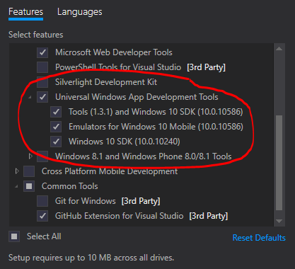

## Validate your Visual Studio Installation

You can validate your Visual Studio installation by selecting Help > About Microsoft Visual Studio. The required version of Visual Studio is 14.0.25123.00 Update 2. The required version of Visual Studio Tools for Universal Windows Apps (aka Tools (1.3.1) and Windows 10 SDK (10.0.10586)) is 14.0.25208.00.

## Install Windows IoT Core Project Templates

Download the template from [here](https://visualstudiogallery.msdn.microsoft.com/55b357e1-a533-43ad-82a5-a88ac4b01dec). Alternatively, the templates can be found by searching for Windows IoT Core Project Templates in the [Visual Studio Gallery](https://visualstudiogallery.msdn.microsoft.com/) or directly from Visual Studio in the Extension and Updates dialog (Tools > Extensions and Updates > Online).

# Provision an Azure Account

If you don’t already have an Azure account, then you will need to provision one.

There are currently two free trail offers – either good for the purposes of the workshop.

1) [Visual Studio Dev Essentials](https://www.visualstudio.com/en-us/products/visual-studio-dev-essentials-vs.aspx) Sign up for free. $25 a month for a year. More slow and steady over an extended period of time.

2) [Free one-month trial](https://azure.microsoft.com/en-us/pricing/free-trial/). Sign up for free and get $200 to spend on all Azure services. Great is you really want to exercise lots of Azure capabilities for a limited period of time.

Valid credit card information is required for identity verification purposes only. Your credit card will not be charged for this offer unless you explicitly remove the spending limit.

If you sign up for Dev Essentials, then be sure to select the Azure offering highlighted below.

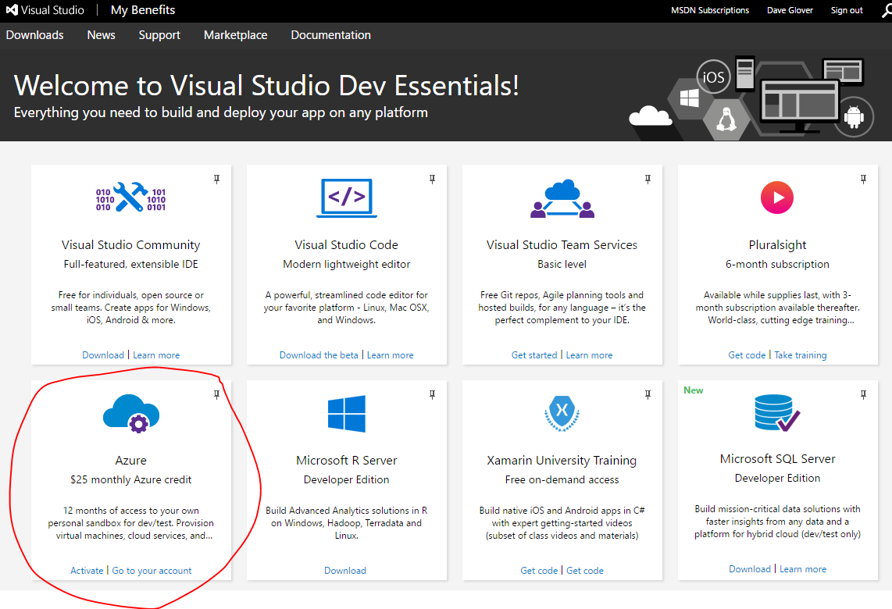

# Install Windows 10 IoT Core Dashboard

See [Get Started with Windows IoT](https://developer.microsoft.com/en-us/windows/iot/getstarted).

From here click “Download Windows 10 IoT Core Dashboard”

To start press the Windows key and type “iot dashboard” run the app and for convenience pin it to your Start screen or taskbar.

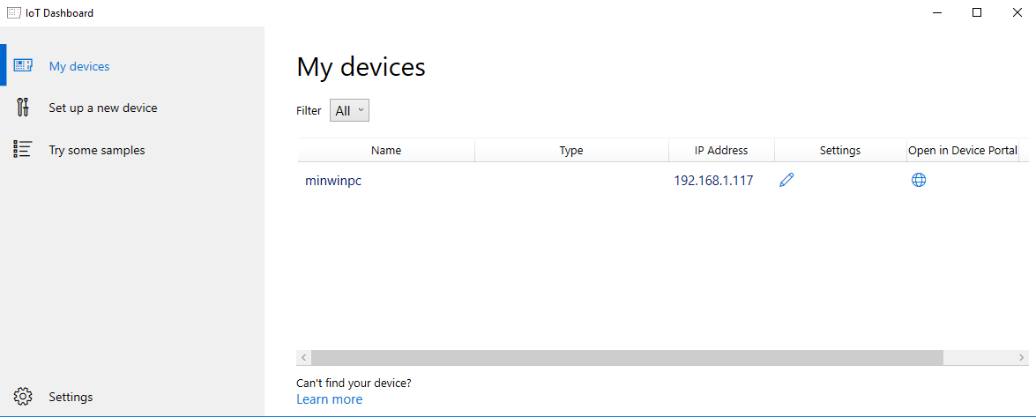

# Install IoT Hub Device Explorer

Azure IoT Hub only allows connections from known devices that present proper credentials. In this lab series you will use the DeviceExplorer utility to provision a device for use in Azure IoT Hub.

A pre-built version of the Device Explorer application for Windows can be downloaded by clicking on this link: [Downloads](https://github.com/Azure/azure-iot-sdks/releases) (Scroll down for **SetupDeviceExplorer.msi**).

To start press the Windows key and type “device explorer” run the app and for convenience pin it to your Start screen or taskbar.

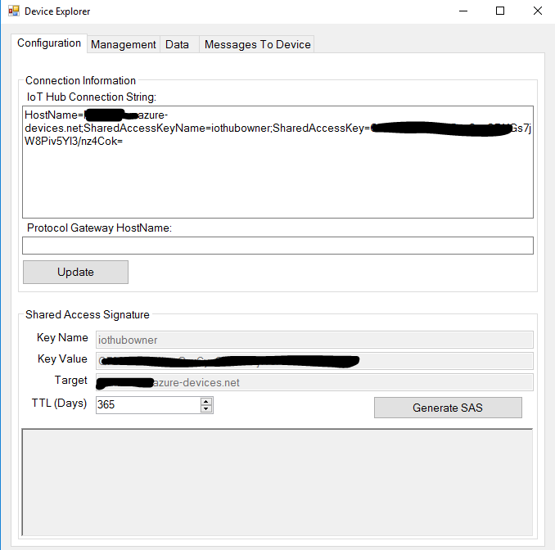

# Install Windows IoT Remote Client

From the Windows App Store install the Windows IoT Remote Client.

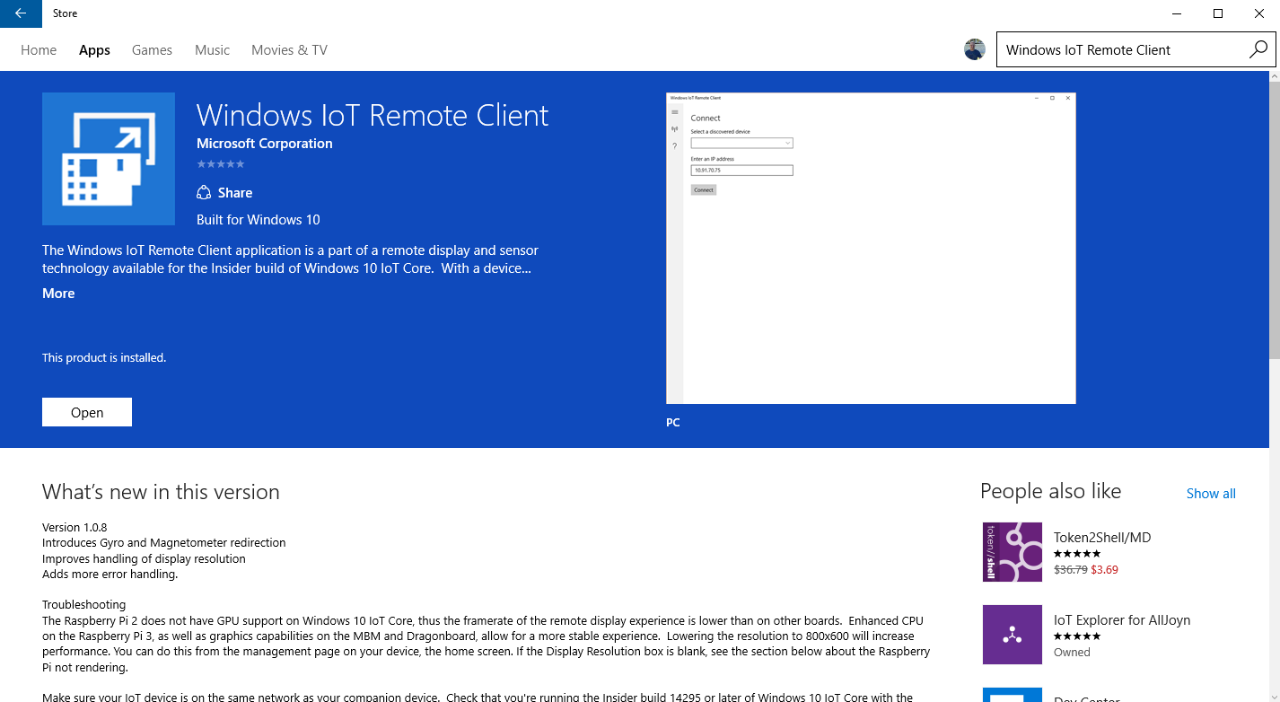

# Pre-Cache Windows IoT Core Nuget Packages

Create and Build a test Windows IoT Core project. The purpose is to pre-cache the required NuGet packages on to your PC.

### Start Visual Studio

New Project -> Windows -> Windows IoT Core -> OK

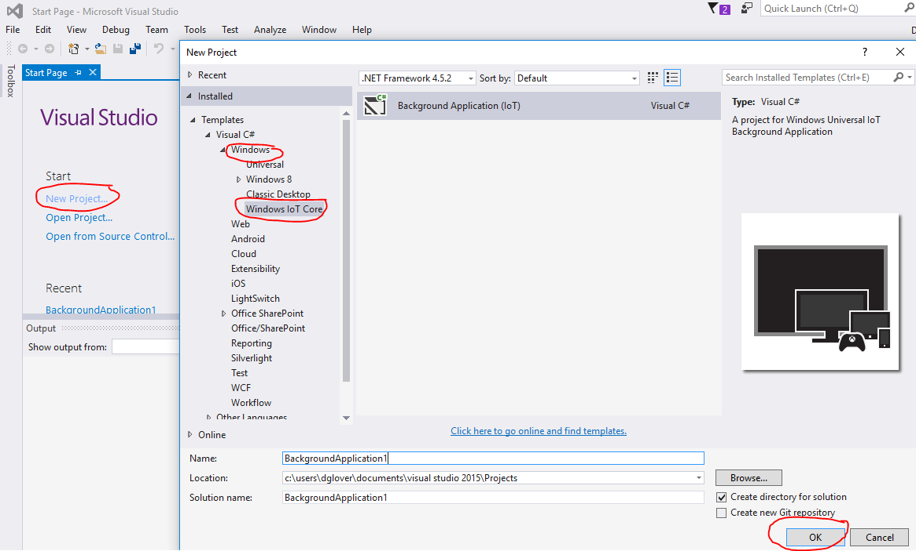

### Select the Defaults

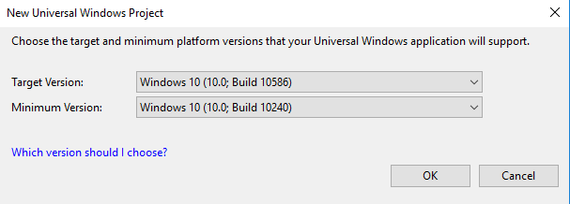

### Build the Project

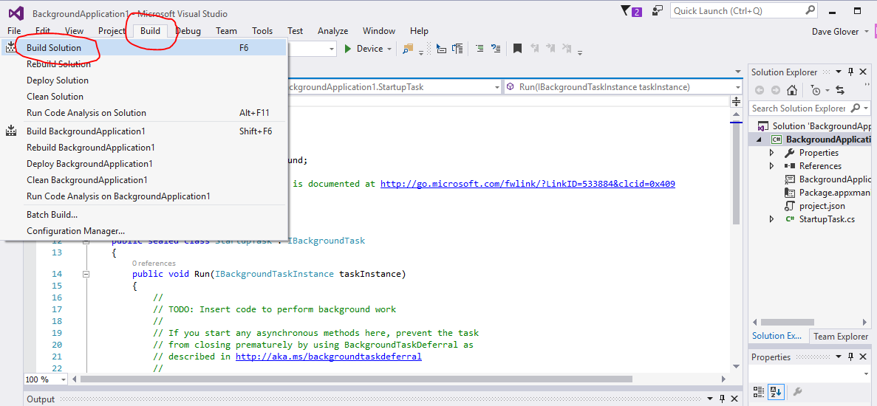

This will download and cache the required NuGet packages.

Ensure successful build

